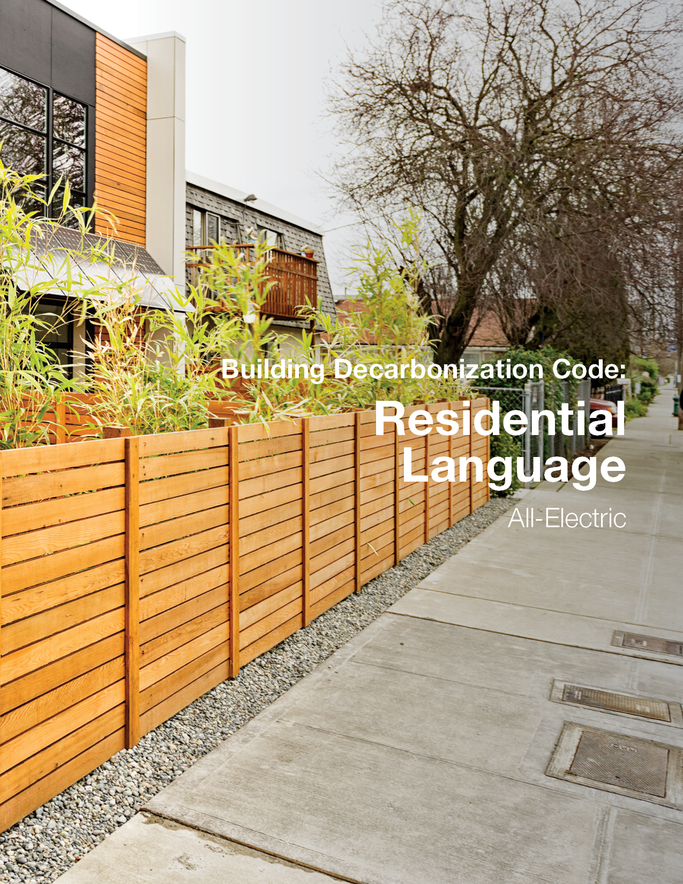

IECC - Residential Provisions (All-Electric)

Chapter 1 – Scope and Application

R101 SCOPE AND GENERAL REQUIREMENTS
Revise text as follows:
R101.3 Intent. This code shall regulate the design, and construction of buildings for the effective use and conservation reduction of greenhouse gas emissions and for the efficient production, use and storage of energy over the useful life of each building. This code is intended to provide flexibility to permit the use of innovative approaches and techniques to achieve this objective. This code is not intended to abridge safety, health or environmental requirements contained in other applicable codes or ordinances.

Intent has been modified to include consideration of greenhouse gas emissions as well as both production and storage of energy.

R103 Construction documents
Add new text as follows:
R103.2.3 Solar-ready system. The construction documents shall provide details for dedicated roof area, structural design for roof dead and live load, and routing of conduit or pre-wiring from solar-ready zone to electrical service panel or plumbing from solar-ready zone to service water heating system for the solar-ready zone shall be represented on the construction documents.
Revisions to this section incorporate critical elements of solar readiness to be clearly identified on the construction documents to allow for easier code compliance review and inspections. This code language has been migrated and amended from the 2021 IECC Appendix RB Solar-Ready Provisions to the most appropriate place in the base code.

R105 INSPECTIONS
Revise text as follows:
R105.2.3 Plumbing rough-in inspection. Inspections at plumbing rough-in shall verify compliance as required by the code and approved plans and specifications as to types of insulation and corresponding R-values and protection and required controls. Where the solar-ready zone is installed for solar water heating, inspections shall verify pathways for routing of plumbing from solar-ready zone to service water heating system.
Revisions to this section incorporate critical elements of solar readiness used for service water heating to allow for inspection enforcement of this provision. This code language is not in the current version of the 2021 IECC Appendix RB Solar-Ready Provisions but is derived from the that language to fully incorporate all aspects of that appendix throughout the base code for enforceability by adopting jurisdictions.

Add new text as follows:
R105.2.5 Electrical rough-in inspection. Inspections at electrical rough-in shall verify compliance as required by the code and the approved plans and specifications as to the locations, distribution, and capacity of the electrical system. Where the solar-ready zone is installed for electricity generation, inspections shall verify conduit or pre-wiring from solar-ready zone to electrical panel.
Current 2021 IECC inspections do not require dedicated electrical inspections. Additional electrical inspection code language that is not in the current version of the 2021 IECC Appendix RB Solar-Ready Provisions but is derived from the that language to fully incorporate all aspects of that appendix throughout the base code for enforceability by adopting jurisdictions.

Revise numbering as follows:
R105.2.5 R105.2.6 Final inspection.

Chapter 2 – Definitions

R202 GENERAL DEFINITIONS
Add new definitions as follows:
ALL-ELECTRIC BUILDING. A building that contains no combustion equipment, or plumbing for combustion equipment, installed within the building, or building site.
APPLIANCE. A device or apparatus that is manufactured and designed to utilize energy and for which this code provides specific requirements.
Definition for appliance is mirrored from 2021 IMC to be useful in defining combustion equipment.
COMBUSTION EQUIPMENT. Any equipment or appliance used for space heating, service water heating, cooking, clothes drying, or lighting that uses fuel gas or fuel oil.
DEMAND RESPONSIVE CONTROL. An automatic control that can receive and automatically respond to demand response requests from a utility, electrical system operator, or third-party demand response program provider.
ELECTRIC VEHICLE (EV). An automotive-type vehicle for on-road use, such as passenger automobiles, buses, trucks, vans, neighborhood electric vehicles, electric motorcycles, and the like, primarily powered by an electric motor that draws current from a rechargeable storage battery, a fuel cell, a photovoltaic array, or another source of electric current. Plug-in hybrid electric vehicles are electric vehicles having a second source of motive power. Off-road, self-propelled electric mobile equipment, such as industrial trucks, hoists, lifts, transports, golf carts, airline ground support equipment, tractors, boats and the like, are not considered electric vehicles.
Definition for EV is mirrored from NEC-2020 to be useful in defining requirements for electric vehicle infrastructure.
EQUIPMENT. Piping, ducts, vents, control devices and other components of systems other than appliances that are permanently installed and integrated to provide control of environmental conditions for buildings. This definition shall also include other systems specifically regulated in this code.
Definition for equipment is mirrored from 2021 IMC to be useful in defining combustion equipment.
EV-READY SPACE. A parking space that is provided with dedicated branch circuit that meets the following requirements:
- Wiring capable of supporting a 40-amp, 208/240-volt circuit,
- Terminates at a junction box or receptacle located within 3 feet (914 mm) of the parking space, and
- The electrical panel directory shall designate the branch circuit as “For electric vehicle charging” and the junction box or receptacle shall be labelled “For electric vehicle charging”.
The definition for EV Ready does not include requirements for minimum capacity for the branch circuit. Different levels of capacity are appropriate for different EV charging scenarios (charging at different building types, parking types, residential types, business types, times of day, etc.) as well as different levels of penetration of EV charging spaces in a parking lot. Therefore, capacity requirements are set in the code text itself to allow for consistent use of the definitions while the capacity requirements change to match the specific EVCI requirements of the jurisdiction. The wiring requirement ensures that the space can be upgraded to a load-managed Level 2 EVSE in the future.
FUEL GAS. A natural gas, manufactured gas, liquified petroleum gas or a mixture of these.
Definition for fuel gas is mirrored from 2021 IMC to be useful in defining combustion equipment.
FUEL OIL. Kerosene or any hydrocarbon oil having a flash point not less than 100°F (38°C).
Definition for fuel oil is mirrored from 2021 IMC to be useful in defining combustion equipment.
MIXED-FUEL BUILDING. A building that contains combustion equipment or includes piping for combustion equipment.

SOLAR-READY ZONE. A section or sections of the roof or building overhang designated and reserved for the future installation of a solar photovoltaic or solar thermal system.
Definition for solar-ready zone has been migrated from the 2021 IECC Appendix RB Solar-Ready Provisions to the base code.

Chapter 4 – Residential Energy Efficiency

R401 GENERAL
Revise text as follows:
R401.2 Application. Residential buildings shall be all-electric buildings and shall comply with Section R401.2.54 and either Sections R401.2.1, R401.2.2, or R401.2.3 or R401.2.4.
The change in application requires that new construction be all-electric. Where a jurisdiction does not wish to require electrification of specific end uses but wants to advance electric buildings further than electric-readiness, exception language can be added. Where exception language is added, electric infrastructure language should be brought over from the mixed-fuel version of the overlay to ensure easy accessibility to future electric equipment installation. Recommended exception language is: Exception: The following combustion equipment is permitted as approved by the code official (list specific equipment types).

Delete section without substitution:
R401.2.2 Total Building Performance Option. The Total Building Performance Option requires compliance with Section R405.
Revise numbering as follows:
R401.2.32 Energy Rating Index Option.
R401.2.43 Tropical Climate Region Option.
R401.2.54 Additional energy efficiency.
The total building performance option has been removed from the residential compliance path options. See additional reasoning under R405. All other sections have been renumbered to reflect removal of this compliance option.

Revise text as follows:
R401.3 Certificate. A permanent certificate shall be completed by the builder or other approved party and posted on a wall in the space where the furnace is located, a utility room or an approved location inside the building. Where located on an electrical panel, the certificate shall not cover or obstruct the visibility of the circuit directory label, service disconnect label or other required labels. The certification shall indicate the following:
4. The types, sizes, and efficiencies of heating, cooling and service water heating equipment. Where a gas-fired unvented room heater, electric furnace or baseboard electric heater is installed in the residence, the certificate shall indicate “gas-fired unvented room heater,” “electric furnace” or “baseboard electric heater,” as appropriate. An efficiency shall not be indicated for gas-fired unvented room heaters, electric furnaces and electric baseboard heaters.
8. Where a solar-ready zone is provided, the certificate shall indicate the location, dimensions, and capacity reserved on the electrical service panel.
Revisions to this section remove vestigial language around “gas-fired” equipment that will not be necessary in an all-electric code and incorporate critical elements of solar readiness to be clearly identified to the original homeowner/building owner and any subsequent owners to allow for easier installation of solar panels. This code language has been migrated from the 2021 IECC Appendix RB Solar-Ready Provisions to the most appropriate place in the base code. By including on the certificate, the information is more likely to remain in the building for future owners.

R402 BUILDING THERMAL ENVELOPE
Delete section without substitution:
R402.4.4 Rooms containing fuel burning appliances.

All electric buildings will not need language that relates to fossil fuel systems. This vestigial language has been removed to avoid confusion in implementation of this overlay.

R403 SYSTEMS
Revise text as follows:
R403.1.1 Thermostat Programmable thermostat. The thermostat controlling the primary heating or cooling system of the dwelling unit shall be capable of controlling the heating and cooling system on a daily schedule to maintain different temperature setpoints at different times of the day. This thermostat shall include the capability to set back or temporarily operate the system to maintain zone temperatures of not less than 55°F (13°C) to not greater than 85°F (29°C). The thermostat shall be programmed initially by the manufacturer with a heating temperature setpoint of not greater than 70°F (21°C) and a cooling temperature setpoint of not less than 78°F (26°C). The thermostat shall be a demand responsive control capable of increasing the cooling setpoint by no less than 4°F (2.2°C) and decreasing the heating setpoint by no less than 4°F (2.2°C) in response to a demand response request.
Demand responsive controls for thermostats are added based on language from California Title 24 and integrated into the current requirement for thermostats.

Add new text as follows:
R403.5.4 Demand responsive water heating. All electric water heating systems with a storage tank larger than 20 gallons (76 L) shall be provided with demand responsive controls that comply with ANSI/CTA-2045-B or another approved demand responsive control.
ANSI/CTA-2045-B standardizes the socket, and communications protocol, for heat pump water heaters so they can communicate with the grid, and with demand response signal providers. In addition, 2045-B adds control and communications requirements for mixing valves in HPWH to enable them to provide greater storage capacity to support increased load shifting. Versions of this standard are included in codes or other requirements in California, Oregon, and Washington.

R404 ELECTRICAL POWER AND LIGHTING SYSTEMS
Revise text as follows:
R404.1.1 Fuel gas lighting equipment. Fuel gas lighting systems shall not have continuously burning pilot lights be installed.
While the use of gas lighting is nearly extinct for both indoor and outdoor new construction uses, gas lamps remain a nostalgic feature in historic neighborhoods. Since the IRC Chapter 24 Fuel Gas does not prohibit the installation of fuel gas lighting, it is critical to ensure that the adoption of this overlay does prohibit these installations.

Add new text as follows:
R404.4 Renewable energy infrastructure. The building shall comply with the requirements of R404.4.1 or R404.4.2
This code language has been migrated from the 2021 IECC Appendix RB Solar-Ready Provisions to the most appropriate place in the base code. By ensuring solar-ready zones, all-electric buildings will have the potential for an even greater impact on building decarbonization by contributing to the continued cleaning of the electricity supply.
R404.4.1 One- and two- family dwellings and townhouses. One- and two-family dwellings and townhouses shall comply with Sections R404.4.1.1 through R404.4.1.4.
Exceptions:
1. A building with a permanently installed on-site renewable energy system.
2. A building with a solar-ready zone area that is less than 600 square feet (55 m²) of roof area oriented between 110 degrees and 270 degrees of true north.
3. A building with a solar-ready zone area that is shaded for more than 70 percent of daylight hours annually.
R404.4.1.1 Solar-ready zone area. The total solar-ready zone area shall be not less than 300 square feet (28 m²) exclusive of mandatory access or set back areas as required by the International Fire Code. Townhouses three stories or less in height above grade plane and with a total floor area less than or equal to 2,000 square feet (186 m²) per dwelling shall have a solar-ready zone area of not less than 150 square feet (14 m²). The solar-ready zone shall be composed of areas not less than 5 feet (1524 mm) in width and not less than 80 square feet (7.4 m²) exclusive of access or set back areas as required by the International Fire Code.
R404.4.1.2 Obstructions. Solar-ready zones shall be free from obstructions, including but not limited to vents, chimneys, and roof-mounted equipment.
R404.4.1.3 Electrical service reserved space. The main electrical service panel shall have a reserved space to allow installation of a dual pole circuit breaker for future solar electric installation and shall be labeled “For Future Solar Electric.” The reserved space shall be positioned at the opposite (load) end from the input feeder location or main circuit location.
R404.4.1.4 Electrical interconnection. An electrical junction box shall be installed within 24 inches (610 mm) of the main electrical service panel and shall be connected to a capped roof penetration sleeve or a location in the attic that is within 3 feet (914 mm) of the solar ready zone by one of the following:
1. Minimum ¾-inch nonflexible conduit
2. Minimum #10 Metal copper 3-wire
Where the interconnection terminates in the attic, location shall be no less than 12” (35 mm) above ceiling insulation. Both ends of the interconnection shall be labeled “For Future Solar Electric”.
As it is currently written, Appendix RB only requires that the construction documents indicate pathways for routing of conduit from the solar-ready zone to the service panel. This update requires the installation and verification of either conduit or wire from the roof or attic to the panel. This language has been adapted from the solar-ready language proposed for the residential Oregon Reach Code.
R404.4.1 Group R occupancies. Buildings in Group R-2, R-3 and R-4 shall comply with Section C405.13.
The 2021 IECC Appendix RB Solar-Ready Provisions address single and two-family dwellings only. Additional language is added to apply the approach for commercial buildings to multifamily residential construction.

Add new text as follows:
R404.5 Electric vehicle charging infrastructure. Electric infrastructure for the current and future charging of electric vehicles shall be installed in accordance with this section. EV ready spaces are permitted to be counted toward meeting minimum parking requirements.
R404.5.1 One- and two- family dwellings and townhouses. One- and two-family dwellings and townhouses with a dedicated attached or detached garage or on-site parking spaces and new detached garages shall be provided with one EV-ready space per dwelling unit. The branch circuit for the EV ready space shall have a minimum capacity of 9.6 kVA.
R404.5.2 Group R occupancies. Parking facilities serving Group R-2, R-3 and R-4 occupancies shall comply with Section C405.15.
Tailored requirements for single-family and multifamily housing have been included. Single-family homes, where the occupants will choose the specific EVSE that meets their EV charging needs, are required to have one parking space with an EV Ready space that is sized to accommodate the most common EVSE on the market. The requirements for EV charging infrastructure for multifamily buildings are referenced to the commercial requirements as those are more appropriate for EV charging in parking lots. The required capacity for the branch circuit for the EV Ready space is the equivalent of a 240V, 40A circuit and is expressed in kVA as that is the standard metric for capacity or “apparent power” in electrical infrastructure.

Section 405 Total building Performance
Delete without substitution:
R405 Total Building Performance
Compliance with the performance path for consideration of greenhouse gas emissions and the needed increased stringency for mixed-fuel buildings requires manipulation of the standard reference design for space heating, water heating, and any other potential combustion end use. Given the limited application of Section R405 in new residential construction, for the purposes of this overlay, compliance via prescriptive path or ERI path create simpler enforcement options for jurisdictions.

Section 406 ENERgy rating index compliance alternative
Revise table as follows:
Table R406.2 Requirements for Energy Rating Index
SECTION | TITLE
Mechanical
R403.5 except Section R403.5.2 | Service hot water systems
R403.5.1 | Heated water circulation and temperature maintenance systems
R403.5.3 | Drain water heat recovery units

The ERI mandatory requirements table has been modified to include the new requirement for demand responsive hot water control. Based on the structure of the table currently, combining R403.5 and creating a single in line exception is the most straightforward approach to this revision.

Revise table as follows:
Table R406.2 Requirements for Energy Rating Index
SECTION | TITLE
Electrical Power and Lighting Systems
R404.1 | Lighting equipment
R404.2 | Interior lighting controls
R404.4 | Renewable energy infrastructure
R404.5 | Electric vehicle charging infrastructure
R406.3 | Building thermal envelope
The ERI mandatory requirements table has been modified to include the new requirements for renewable energy and electric vehicle charging as mandatory elements of the code amendments.

R407 TROPICAL CLIMATE REGION COMPLIANCE PATH
Revise text as follows:
R407.2 Tropical climate region. Compliance with this section requires the following:
1. Not more than one-half of the occupied space is air conditioned and is controlled by a thermostat in accordance with Section R403.1.1.
3. Solar, wind or other renewable energy source supplies not less than 80 percent of the energy for service water heating controlled in accordance with Section R403.5.4.
12. Parking is in accordance with Section R404.6.
Modifications to the Tropical Climate Region Path are minimal. This pathway in the 2021 IECC already does not allow any space heating and requires 80% of hot water be supplied by renewable energy. To ensure the inclusion of demand response controls, electric vehicles, and all other combustion equipment is addressed additional requirements are added to the tropical compliance list under R407.2.

R408 ADDITIONAL EFFICIENCY PACKAGE OPTIONS
Revise text as follows:
R408.2.2 More efficient HVAC equipment. Heating and cooling equipment shall meet one of the following efficiencies:
1. Greater than or equal to 95 AFUE natural gas furnace and 16 SEER air conditioner.
21. Greater than or equal to 10 HSPF/16 SEER air source heat pump.
32. Greater than or equal to 3.5 COP ground source heat pump.

R408.2.3 Reduced energy use in service water-heating option. The hot water system shall meet one of the following efficiencies:
1. Greater than or equal to 82 EF fossil fuel service water-heating system.
21. Greater than or equal to 2.0 EF electric service water-heating system.
32. Greater than or equal to 0.4 solar fraction solar water-heating system.

All electric buildings will not need language that relates to fossil fuel systems. This vestigial language has been removed to avoid confusion in implementation of this overlay and the sections have been renumbered.

Chapter 6 – Referenced Standards
Add new standard as follows:
CTA | Consumer Technology Association  1919 S. Eads Street  Arlington, VA 22202
Standard  reference  number | Title | Referenced  in code  section number
ANSI/CTA-2045-B | Modular Communications Interface for Energy Management . . . . . . . | . . . . . . . R403.5.4

